Public transport optimization

Submitted by

V.Sakthisri

Au723921106017

Sakthisree572003@gmail.com

Table Of Contents :

* Abstract
* Objectives
* Working
* Block Diagram
* Work flow
* Flow chart Design
* Connected mobile apps with public transport optimization
* Simulation
* Applications
* Advantages
* Disadvantages
* Conclusion

Abstract:

*A public transport optimization project aims to To embark on such a project, you can follow these design thinking steps improve the efficiency, accessibility, and sustainability of public transportation systems within a specific region or city*

*Public transport optimization is an ongoing process, and advances in technology, data analytics, and urban planning continue to drive improvements in public transportation systems worldwide. The goal is to create a convenient, reliable, and attractive alternative to private car travel, which can reduce congestion, lower emissions, and improve overall urban mobility*

#### Public transport optimization is a multifaceted field that encompasses a wide range of strategies, technologies, and practices to enhance the efficiency and effectiveness of public transportation systems.

#### It is a very complicated problem because planners must take into account multiple competing criteria (e.g., service requirements, asset utilization, cost minimization, workload fairness, etc.), components of the transportation system, and their interconnection. Moreover, transportation planners should consider many factors to create efficient plans, including but not limited to vehicle and driver availability, vehicle size and capacity, traffic details, travel time windows, and passengers’ locations, which are too many for one to handle efficiently in his head. On the other hand, plans often are required to be modified later due to unexpected events, such as vehicle breakdown, drivers’ sickness, and severe weather conditions, which make transportation planning even more complex. However, many transportation planners still create their transportation plans manually without using any tool that is equipped with advanced technologies, which is very hard and time-consuming for even the most experienced planners. Besides, increasing demand for faster planning, increasing pressure to reduce transportation costs through better decision making, and increasing complexity of transportation problems due to a significant increase in the size of transportation networks make manual transportation planning almost impossible.

**Objective:**

#### Effective public transport systems play a pivotal role in the development and sustainability of urban areas. They are vital in reducing traffic congestion, air pollution, and carbon emissions, while simultaneously increasing accessibility and convenience for residents and visitors. However, many cities face challenges in optimizing their public transport networks to meet the growing demands of urbanization, changing commuter preferences, and technological advancements. This Public Transport Optimization Project is designed to address these challenges and create a more efficient and sustainable public transport system.

#### The Public Transport Optimization Project aims to improve the efficiency, accessibility, and sustainability of the existing public transport network in [City Name]. By leveraging data analytics, technology, and innovative strategies, the project will identify key areas of improvement, develop solutions, and implement changes that benefit both commuters and the environment. This project will take a holistic approach, considering the needs of diverse stakeholders, from the citizens who rely on public transport to the city's policymakers and urban planners.

Working :

The working process of public transport optimization involves a series of steps and strategies to enhance the efficiency and effectiveness of a public transportation system. Here's a simplified overview of the process:

1. Data Collection and Analysis:

#### The process begins with collecting various types of data, including passenger demand, travel patterns, system performance, and infrastructure details.

#### Data analysis helps transit agencies understand current usage patterns, identify bottlenecks, and determine areas where optimization is needed.

#### Demand Forecasting:

* Using historical data and predictive modeling, transit agencies forecast future passenger demand. This is critical for resource allocation and route planning

1. Route Planning
   * Based on demand forecasts and data analysis, transit agencies plan or adjust routes to maximize efficiency. This may involve creating direct routes, minimizing detours, and ensuring routes connect key destinations.

#### 4. Scheduling:

#### Transit agencies create schedules that optimize service frequency and capacity to meet peak and off-peak demands. Schedules should minimize passenger

#### 5. Integration:

#### Public transport systems are integrated, allowing passengers to easily transfer between different modes of transportation, such as buses, trains, and trams.

#### 6. Real-Time Monitoring:

#### Public transport services are equipped with real-time monitoring systems that track vehicle locations and provide data to transit agencies and passengers.

#### 7. Real-Time Information:

#### Passengers receive real-time information through apps, websites, or displays at transit stops. This information helps passengers plan their journeys and adapt to service disruptions.

#### .8. Fare Systems:

#### Modern fare systems are implemented, allowing passengers to pay using contactless methods, mobile apps, and integrated ticketing across different modes.

#### 9. Infrastructure Improvements:

#### Infrastructure enhancements, such as dedicated bus lanes, transit signal priority, and accessibility features, are implemented to improve system efficiency and passenger experience.

#### 10. Environmental Considerations:

#### Public transport optimization includes environmentally friendly practices, such as electric buses or trains powered by renewable energy sources to reduce emissions.

#### 11. Accessibility and Inclusivity:

#### Efforts are made to ensure that public transport systems are accessible to all passengers, including those with disabilities, and meet diverse transportation needs.

#### 12. Policy and Funding:

#### Supportive government policies, funding mechanisms, and regulations play a critical role in enabling public transport optimization initiatives.

#### 13. Continuous Improvement:

#### Public transport optimization is an ongoing process. Transit agencies use feedback, data, and lessons learned to continuously improve services, adapt to changing conditions, and meet evolving passenger needs.

#### The working process of public transport optimization relies on data, technology, planning, and ongoing adjustments to create a reliable, convenient, and attractive public transportation system that efficiently serves the needs of the community while promoting sustainable and environmentally friendly alternatives to private car travel.

#### Block Diagram :

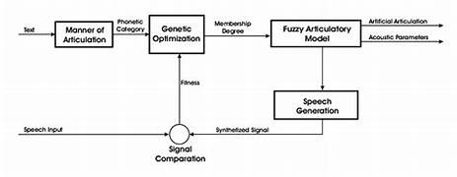

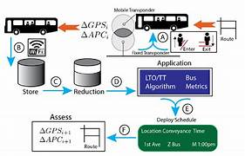

Work Flow:

*When the bus arrives to a specific stop the barcode reader in the bus reads the code and opens the door through which the passenger can get in and also get out of the bus. The opens automatically if the code matches without the help of the bus driver. The door closed automatically after 5 min delay which will be a sufficient to board and departure the bus.*

***Algorithm for software demonstration:***

***1.*** *Open the Eclipse Luna (Java IDE).*

***2.*** *Select the main page and run as java application. Then, select com port to which system is connected through USB port.*

***3.*** *Set all the properties i.e. baud rate, parity bits, start and stop bits accordingly.*

***4.*** *As soon as properties are set, it displays no. of persons available and when location tracking switch pressed, it gets the location as latitude and longitude values on the main page.*

***5.*** *Then, run the main project on run on server and then finish by selecting Tomcat v8.0 Server at local host.*

***6.*** *Then, the application page on browser opens.*

***7.*** *At homepage, search options are provided for bus searching.*

***8.*** *When searched for bus, it displays the bus details and location to track the bus.*

***9.*** *If track pressed, then on Google map displays the current real-time location*

Flow Chart Design:

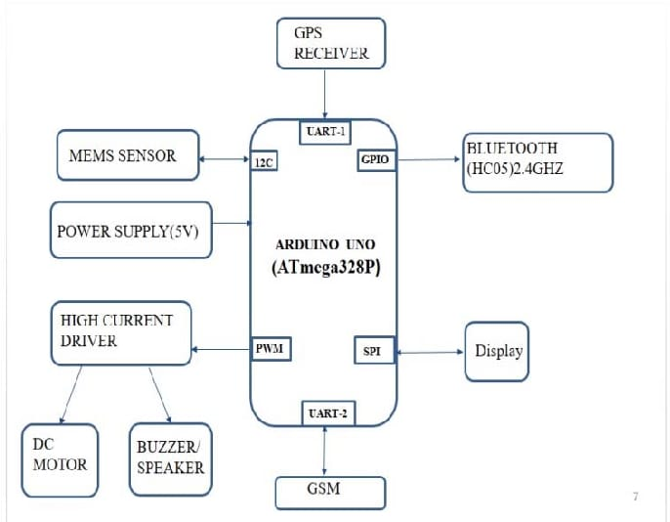

* Connected mobile apps with public transport optimization

*Here's a high-level overview of the steps to achieve this connection: Connecting a mobile app to a Public Transport Optimization IoT project involves setting up a communication pathway between the mobile app and the IoT devices or backend server.*

#### 1.Define App Requirements:

#### Determine the specific functionalities and features you want to offer in the mobile app. These could include real-time tracking, route information, alerts, and notifications

#### 2.Choose Development Platforms:

#### Decide whether you want to develop native apps for specific platforms (e.g., iOS and Android) or use cross-platform frameworks like React Native, Flutter, or Xamarin to build the app for multiple platforms simultaneously.

#### 3.Select Development Tools

#### Choose the development tools and integrated development environments (IDEs) suitable for the selected platform and framework.

#### 4.Develop Mobile App:

#### Create the mobile app using the chosen platform and development tools. Integrate user interfaces, real-time tracking, and any other relevant features.

#### 5.Implement Communication:

#### To connect the app with IoT devices or the backend server:

#### 1.APIs: Develop RESTful or WebSocket APIs on the backend server to expose data and functionality to the app.

#### 2.Mobile App Client: Implement communication within the app using libraries like fetch (for HTTP requests), WebSockets, or specialized IoT communication protocols (e.g., MQTT).

#### 6.Authentication and Security:

#### Implement user authentication mechanisms to ensure secure access to the app.

#### Ensure data security by using encryption and authentication methods, especially when dealing with sensitive data.

#### 7.User-Friendly Interfaces:

#### Create user-friendly interfaces within the app to display real-time information and allow users to interact with the Public Transport Optimization system.

#### 8.Push Notifications:

#### Implement push notification services to send real-time alerts and updates to the mobile app users. This could be for service delays, route changes, or other relevant information.

#### 9.Testing:

#### Thoroughly test the app's functionality, performance, and user experience to ensure it works seamlessly with the IoT system.

#### 10.Deployment:

#### Deploy the mobile app to app stores (e.g., Apple App Store, Google Play Store) for public or limited access.

#### 11.Maintenance and Updates:

#### Continuously monitor the app's performance and user feedback. Address issues, release updates, and add new features as needed.

Simulation

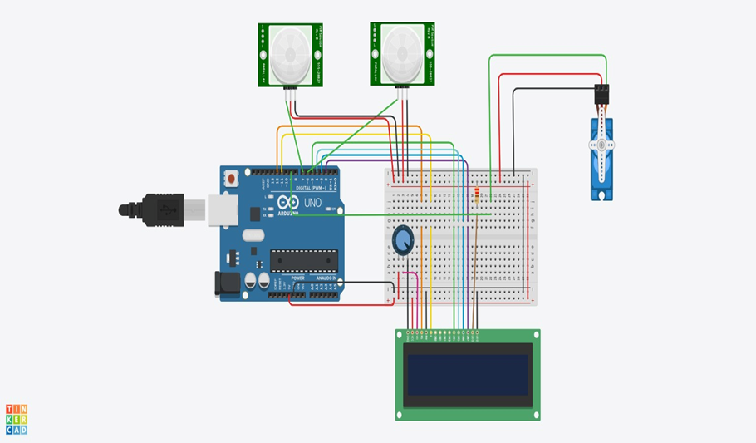

Applications:

*Public transport optimization plays a crucial role in improving the efficiency, accessibility, and sustainability of urban transportation systems. Here are several key applications of public transport optimization:*

*1. Route Planning and Scheduling:*

* + *Optimizing bus, tram, and subway routes to ensure they cover high-demand areas while minimizing travel time and maximizing passenger convenience.*
  + *Developing timetables that reduce waiting times for passengers and improve overall system efficiency.*

*2. Fleet Management:*

* + *Optimizing the size and composition of the public transport fleet to match demand, reduce operational costs, and minimize emissions.*
  + *Implementing maintenance schedules to ensure vehicles are in good working condition.*

*3. Fare Pricing and Revenue Management:*

* + *Implementing dynamic pricing strategies that adjust fares based on demand, time of day, and route.*
* *Managing fare collection systems, including contactless payments and digital ticketing, to improve revenue collection and streamline passenger boarding.*

*4. Integration with Other Transport Modes:*

* + *Integrating public transport services with other transportation modes, such as cycling, walking, and ride-sharing, to provide seamless multi-modal journeys for passengers.*

*5. Passenger Information and Communication:*

* + *Developing real-time information systems that provide passengers with updates on service disruptions, vehicle locations, and estimated arrival times.*
  + *Utilizing mobile apps and websites to help passengers plan their journeys and access up-to-date information.*

*6. Demand-Responsive Services:*

* + *Implementing on-demand transit services in low-density or underserved areas to reduce the operational costs of traditional fixed-route services.*
  + *Using data analytics to adjust service availability and coverage in real time based on demand fluctuations.*

*7. Infrastructure and Stop Planning:*

* + *Optimizing the location and design of transit stops and stations to enhance accessibility and passenger convenience.*
  + *Ensuring that public transport infrastructure is compliant with accessibility requirements for individuals with disabilities.*

*8. Environmental Sustainability:*

* + *Transitioning to cleaner and more energy-efficient vehicles to reduce the environmental impact of public transport.*
  + *Implementing strategies to reduce greenhouse gas emissions, such as electrification and the use of alternative fuels.*

*9. Safety and Security:*

* + *Implementing safety measures to protect passengers and employees, including surveillance systems and emergency response protocols.*
  + *Optimizing routes to minimize exposure to high-crime areas and enhancing security at transit stations.*

*10. Data Analytics and Predictive Maintenance:*

* + *Leveraging data analytics and predictive maintenance to reduce downtime and increase the reliability of the public transport fleet.*
  + *Using data to identify and address service bottlenecks and areas where improvements are needed.*

*11. Accessibility and Inclusivity:*

* + *Ensuring that public transport services are accessible to people with disabilities, the elderly, and other vulnerable populations.*
  + *Optimizing services to address the specific needs of different communities and demographics.*

*12. Policy and Funding Allocation:*

* + *Informing policymakers and transit authorities with data-driven insights to support funding allocation and decision-making for public transport improvements.*

*Advantages :*

*Public transport optimization offers a wide range of advantages, both for individuals and communities, as well as for the environment and the economy. Here are some key benefits of optimizing public transportation systems:*

*1. Reduced Traffic Congestion:*

*- Efficient public transport systems can help reduce the number of private vehicles on the road, which in turn eases traffic congestion and decreases travel times for everyone.*

*2. Environmental Benefits:*

*- Reduced emissions: Public transport optimization can lead to the use of cleaner, more fuel-efficient vehicles, which helps lower greenhouse gas emissions and air pollution.*

*- Reduced energy consumption: Public transport is generally more energy-efficient per passenger mile than private vehicles.*

*3. Cost Savings:*

*- Lower personal transportation expenses: Public transportation is often more cost-effective than owning and maintaining a private vehicle, especially when factoring in fuel, insurance, maintenance, and parking costs.*

*4. Improved Mobility:*

*- Enhanced accessibility: Public transport provides reliable and affordable transportation options for people who do not own a car, including those with disabilities, the elderly, and low-income individuals.*

*- Connectivity: Integrated public transport systems offer seamless connections between different modes of transportation, making it easier for passengers to reach their destinations.*

*5. Economic Benefits:*

*- Job creation: The development and maintenance of public transport systems can stimulate economic growth by creating jobs in construction, operations, and maintenance.*

*- Increased property values: Well-planned and accessible public transport can increase property values in the areas it serves.*

*6. Safety:*

*- Public transport is generally safer than private vehicles, with lower rates of accidents and fatalities per passenger mile.*

*7. Reduced Energy Dependency:*

*- Reduced dependence on fossil fuels: By promoting the use of public transport, countries can reduce their reliance on oil and other finite resources.*

*8. Land Use and Urban Planning:*

*- Encouraging more sustainable urban development: Public transport optimization can influence land-use decisions, encouraging denser, mixed-use developments around transit hubs, which reduces urban sprawl.*

*9. Lower Infrastructure Costs:*

*- Building and maintaining public transport infrastructure is often less expensive per passenger mile than continually expanding road networks and building more highways.*

*10. Social Inclusion:*

*- Public transport optimization can help bridge social and economic disparities by ensuring that everyone, regardless of income or physical abilities, has access to transportation services.*

*11. Reduced Parking Demand:*

*- Public transport optimization can lead to decreased demand for parking facilities in urban areas, freeing up land for other uses.*

*12. Public Health:*

*- Encouraging active transportation: Public transport often involves walking or cycling to and from transit stops, promoting physical activity and better health.*

*- Improved air quality: Reduced vehicle emissions due to optimized public transport contribute to cleaner air and improved public health.*

*13. Resilience and Disaster Response:*

*- Public transport systems can serve as lifelines during emergencies and natural disasters, providing evacuation routes and transport for first responders.*

*14. Long-Term Sustainability:*

*- Public transport optimization is an essential component of sustainable urban and regional development, supporting the long-term well-being of communities.*

*Disadvantages*

*While public transport optimization offers numerous advantages, there are also some potential disadvantages and challenges associated with the implementation and operation of optimized public transportation systems. These drawbacks can vary depending on the specific circumstances and the extent to*

*1. Initial Implementation Costs:*

*- Developing and implementing a well-optimized public transport system often requires significant financial investments in infrastructure, vehicles, technology, and personnel, which can be a barrier for some regions and municipalities.*

*2. Ongoing Operating Costs:*

*- Maintaining and operating an optimized public transport system, including employee salaries, vehicle maintenance, and fuel or energy costs, can be a continuing financial burden.*

*3. Resistance to Change:*

*- Passengers and communities may resist changes in public transport services, such as route adjustments, fare increases, or the introduction of new technologies, leading to initial pushback.*

*4. Political and Bureaucratic Challenges:*

*- Public transport optimization may be subject to political decisions and bureaucratic inefficiencies that can impede the implementation of best practices and hinder decision-making processes.*

*5. Coverage vs. Ridership Trade-Off:*

*- Balancing the coverage of a wide area with high ridership routes can be challenging. Sometimes, optimizing for one may result in a reduction in the other, leaving some areas underserved.*

*6. Disruptions during Implementation:*

*- Construction and service disruptions associated with building new infrastructure or upgrading existing systems can inconvenience passengers and local businesses.*

*7. Equity Concerns:*

*- Optimizing public transport systems can unintentionally exclude or disadvantage vulnerable populations, such as low-income individuals*

*8. Infrastructure Challenges:*

*- Aging or inadequate infrastructure may require significant upgrades to accommodate optimized public transport systems, which can be costly and disruptive.*

*9. Limited Flexibility:*

*- Optimized systems may be less adaptable to sudden changes in demand or emergencies, such as natural disasters or unforeseen events.*

*10. Technological Dependency:*

*- Public transport optimization often relies on advanced technology, such as scheduling software and real-time tracking systems, which can be vulnerable to technical glitches or cyberattacks.*

*11. Service Gaps:*

*- In some cases, optimized routes may lead to service gaps, leaving certain areas without public transport access, particularly in low-density or remote regions.*

*12. Public Safety Concerns:*

*- Crowding and security issues in public transport can be a concern, particularly during peak hours or in certain neighborhoods.*

*13. Competition with Other Modes:*

*- Public transport optimization may face competition from alternative transportation modes, such as ride-sharing and autonomous vehicles, which can disrupt established transit systems.*

*14. Perceived Inconvenience:*

*- Passengers may perceive optimized systems as less convenient if changes result in longer walks to transit stops or more transfers between routes.*

*It's important to note that many of these disadvantages can be mitigated with careful planning, community engagement, and policy decisions that prioritize accessibility and equity. Public transport optimization should aim to balance the potential drawbacks with the numerous benefits it offers, ultimately striving to provide efficient, reliable, and inclusive transportation services.*

*Conclusion*

*The life of a human is more important. All the invention and discoveries made are to in human life. In public bus transportation accident caused due to whoever may be the problem is faced by the government and it also affects the law-and-order. We strongly believe that our methodology can reduce the death rate due to foot board travel and boarding the bus while the bus is in movement. The over loading of the bus can vanish if the methodology which we have proposed is followed. Apart from this by automating the bus ticket, we can reduce the cheating done and also reduce the loss due to the bus transportation for the government to a great extent. Using of Cloud to store data can provide much memory to store the* *data about the passenger and bus. The transportation smart card can also be use for passenger safety also. Since we have used the technology IoT for the communication, it will be suitable for the further upgrade of the methodology proposed.*

#### Public transport optimization is essential for reducing traffic congestion, emissions, and improving urban mobility. Effective strategies include route planning, technology integration, and sustainable infrastructure development, ultimately enhancing accessibility and the quality of life in cities.